 |  | 
 | Apple iPhone 8GB
 | 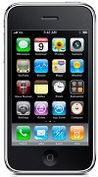 | Description  The Apple iPhone provides its user with the ultimate mobile device which include high  quality features & stunning design concept. its is a mobile phone,a highly useable wide  screen iPod with touch screen controls & a Internet communications device.  STORE PRICE: Rs 27,981 /-  ONLINE PRICE: Rs 27,884 /-
Brand : Apple
Model Name : iPhone 8GB
Released Year : 2008
Phone Memory : 16 GB shared memory
External Memory : No
Colors : Black, White
Form : Bar
Dimensions : 115.5 x 62.1 x 12.3 mm

